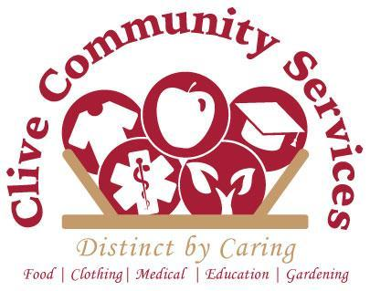

Board of Directors Candidate Application

Thank you for your interest in joining the Clive Community Services Board of Directors. Please complete and return to 2190 NW 82nd St Ste A, Clive, IA 50325 or email president@clivecommunityservices.com.

Date: __________________________

Name: _____________________________________________________________________

Address: ____________________________________________________________________

Phone: _____________________________________________________________________

Email: ______________________________________________________________________

Employer: ___________________________________________________________________

Your Title: _____________________________________________________________

Phone: _______________________________________________________________

Email: ________________________________________________________________

Type of Business or Organization: __________________________________________

Preferred Method of Contact: ____________________________________________________

Why are you interested in serving on the CCS Board?

____________________________________________________________________________

____________________________________________________________________________

What would you like to contribute to the organization as a Board Member?

____________________________________________________________________________
____________________________________________________________________________

What do you hope to gain by becoming a member of this board?

____________________________________________________________________________

____________________________________________________________________________

Please list boards, committees and other significant roles with other organizations you have served with, past or present (business, civic, community, fraternal, political, religious, recreational).

____________________________________________________________________________

____________________________________________________________________________

Please list any groups, organizations, or businesses that you could serve as a liaison to on behalf of CCS.

____________________________________________________________________________

____________________________________________________________________________

Education/Training/Certifications:

____________________________________________________________________________

____________________________________________________________________________

Skills, Experience, Interests (select all that apply):

Finance and Accounting

Human Resources

Information Technology/Website Management

Nonprofit Management

Legal/Attorney

Fundraising

Grant Writing

Policy Development

Public Relations, Communications

Special Events Coordination

Volunteer Management

Outreach, Advocacy

Other

Please tell us anything else you would like to share.

____________________________________________________________________________

____________________________________________________________________________

____________________________________________________________________________

____________________________________________________________________________

____________________________________________________________________________

Updated 8/30/19 LE

